

**SWE30010 - Managing IT Projects**

**TASK 13: Sprint Retrospective**

HUMAN RESOURCE MANAGEMENT WITH

ATTENDANCE SYSTEM

*Group 2*

**GROUP 2 INFORMATION**

| **Name** | **ID** | **Tutor** | **Class** |
| --- | --- | --- | --- |
| Le Hoang Hai | 103542974 | Thomas Hang  Nsam@swin.edu.au | Saturday  7:00 AM |
| Nguyen Dinh Nhat Minh | 103802490 |
| Nguyen Nhat Huy | 103802911 |
| Nguyen Ngoc Minh Thy | 103802791 |

**Introduction**

After our first sprint is completed, we feel the need to revisit the process of completing our sprint to get a better understanding of what we have done that is capable and what we could have done better. To assist this task, we will attempt to answers some retrospective question as well as document further ideas that our teams has about this sprint.

1. **Sprint Retrospective**
2. **Team’s velocity**

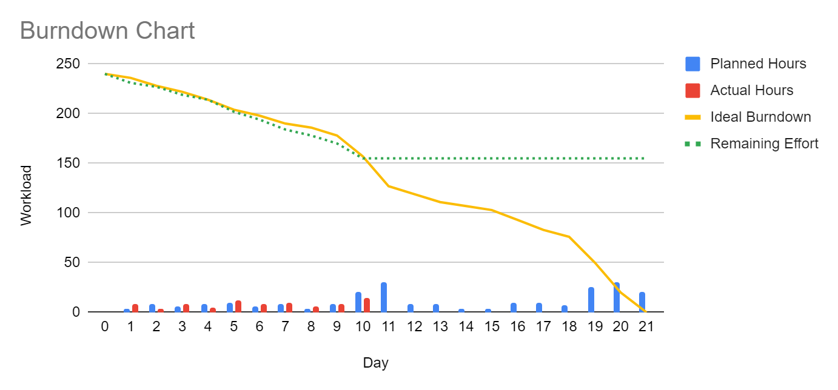

*Figure 1.1: Burndown Chart*

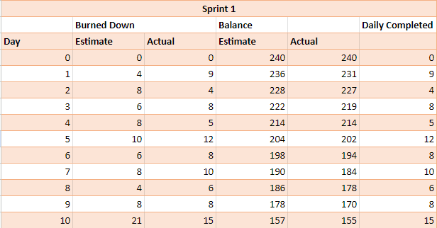

*Figure 1.2: Burndown Table*

* Did your team over-estimate your ability? Or Did you under-estimate the effort required to complete the tasks?
* Analysing our team's burndown chart for the initial ten days of the sprint, it appears we may have slightly underestimated the effort required to finish each product within the sprint. However, this discrepancy isn't major, as we're managing to wrap up some work that has been planned later ahead of time. It still highlights the need for us to meticulously reconsider and tweak our approach to subsequent sprint products, which involves breaking down heavier tasks and allocating them to days with fewer hours required, thereby balancing out the days that demand more effort.
* What can you do in order to get a better understanding of the "complexity" of the tasks required? Or What can you do in order to get better time estimates next time?
* We need to perform regular review with our tutor to refine our plan and adjust our effort accordingly. We would also benefit from observing the plan of other professionals, whose template can be found from the internet.
* We also need to break down tasks into more detailed descriptions or create additional subtasks for our product's main tasks. This is necessary because we sometimes struggle to keep track of all the tasks we need to do. Moreover, as the project nears completion, the scope of our product expands, and we lack a formal method of recording all the new tasks that arise.

1. **Team’s process**

* What is working? Why?
* Our team's communication is quite effective. We use various channels like Messenger, Discord, and Trello to exchange information about tasks, deadlines, and other notes. This advantage enables us to swiftly pass on new information as soon as it's available.
* Task allocation is also well done in my opinion. Each team member gets to showcase their strengths. For example, designers handle mockups and writing, developers create and run websites, and the leader handles review and quality control. Overall, I believe our team dynamics are solid.
* What is not working? Why not? Any suggestions to improve the situation if this occurs in the future?
* Our time management and handling of heavy tasks could be improved. We often make tasks too large and fail to break them down into sufficient detail. As a result, allocating time to these large tasks becomes inaccurate upon closer examination, leading to tight deadlines and lower-quality outcomes.
* Suggestions for improvement are listed on the former parts, however, our team agrees that in order for our processes and dynamics to be more fluid, we should plan a few weeks further for tasks that have been defined. Moreover, regular meeting to review tasks done by every members would be beneficial.